**Problem Solving**

**Solving Various Problems Using C Language**

*Summer Internship Report Submitted in partial fulfillment*

*of the requirement for under graduate degree of*

**Bachelor of Technology**

In

**Computer Science Engineering**

By

**D.Sahith**

**221710313047**

*Under the Guidance of*

**Mr. M. Venkateswarlu**

Assistant Professor



Department Of Electronics and Communication Engineering

GITAM School of Technology

GITAM (Deemed to be University)

Hyderabad-502329

July 2020

**DECLARATION**

I submit this industrial training work entitled **“Solving various Problems Using C Language**” to GITAM (Deemed To Be University), Hyderabad in partial fulfillment of the requirements for the award of the degree of “**Bachelor of Technology**” in “**Computer Science Engineering**”. I declare that it was carried out independently by me under the guidance of  **Mr. M. Venkateswarlu**, Asst. Professor, GITAM (Deemed To Be University), Hyderabad, India.

The results embodied in this report have not been submitted to any other University or Institute for the award of any degree or diploma.

Place: HYDERABAD                  D.Sahith

Date:       221710313047

GITAM (DEEMED TO BE UNIVERSITY)

Hyderabad-502329, India

Dated:

**CERTIFICATE**

This is to certify that the Industrial Training Report entitled **“PREDICTING AMOUNT OF PURCHASE”** is being submitted by D.sahith (221710313047) in partial fulfillment of the requirement for the award of **Bachelor of Technology** **in Computer Science Engineering** at GITAM (Deemed To Be University), Hyderabad during the academic year 2020-21

It is faithful record work carried out by her at the **Computer** S**cience Engineering Department**, GITAM University Hyderabad Campus under my guidance and supervision.

**Mr.Venkateswarlu                                         Dr.K.Manjunathachari** Assistant Professor                                           Professor  and HOD

Department of CSE                                     Department of CSE

**ACKNOWLEDGEMENT**

Apart from my effort, the success of this internship largely depends on the encouragement and guidance of many others. I take this opportunity to express my gratitude to the people who have helped me in the successful competition of this internship.

I would like to thank respected **Dr. N. Siva Prasad,** Pro Vice Chancellor, GITAM Hyderabad and **Dr. CH. Sanjay,** Principal, GITAM Hyderabad

I would like to thank respected **Dr. K. Manjunathachari,** Head of the Department of Electronics and Communication Engineering for giving me such a wonderful opportunity to expand my knowledge for my own branch and giving me guidelines to present a internship report. It helped me a lot to realize of what we study for.

I would like to thank the respected faculties **Mr. M. Venkateswarlu** who helped me to make this internship a successful accomplishment.

I would also like to thank my friends who helped me to make my work more organized and well-stacked till the end.

                                                                                               D.SAHITH

                                                                                                               221710313047

**TABLE OF CONTENTS**

**[1 Introduction to the project 1](https://docs.google.com/document/d/1tjcjW_gBxLXJJ8lcM_zoOmIZgnojR5jVKL0I-zXZKt8/edit" \l "heading=h.gjdgxs)**

**[2  Problem 1 2](https://docs.google.com/document/d/1tjcjW_gBxLXJJ8lcM_zoOmIZgnojR5jVKL0I-zXZKt8/edit" \l "heading=h.30j0zll)**

[2.1 Problem Statement:-](https://docs.google.com/document/d/1tjcjW_gBxLXJJ8lcM_zoOmIZgnojR5jVKL0I-zXZKt8/edit" \l "heading=h.1fob9te) 2

[2.2 Coding](https://docs.google.com/document/d/1tjcjW_gBxLXJJ8lcM_zoOmIZgnojR5jVKL0I-zXZKt8/edit" \l "heading=h.3znysh7) 4

[2.3 Output](https://docs.google.com/document/d/1tjcjW_gBxLXJJ8lcM_zoOmIZgnojR5jVKL0I-zXZKt8/edit" \l "heading=h.2et92p0) 4

**[3  Problem 2 5](https://docs.google.com/document/d/1tjcjW_gBxLXJJ8lcM_zoOmIZgnojR5jVKL0I-zXZKt8/edit" \l "heading=h.tyjcwt)**

[3.1 Problem Statement:-](https://docs.google.com/document/d/1tjcjW_gBxLXJJ8lcM_zoOmIZgnojR5jVKL0I-zXZKt8/edit" \l "heading=h.3dy6vkm) 5

[3.2 Coding](https://docs.google.com/document/d/1tjcjW_gBxLXJJ8lcM_zoOmIZgnojR5jVKL0I-zXZKt8/edit" \l "heading=h.1t3h5sf) 7

[3.3 Output](https://docs.google.com/document/d/1tjcjW_gBxLXJJ8lcM_zoOmIZgnojR5jVKL0I-zXZKt8/edit" \l "heading=h.4d34og8) 7

**[4  Problem 3](https://docs.google.com/document/d/1tjcjW_gBxLXJJ8lcM_zoOmIZgnojR5jVKL0I-zXZKt8/edit" \l "heading=h.2s8eyo1)**  **8**

[4.1 Problem Statement:-](https://docs.google.com/document/d/1tjcjW_gBxLXJJ8lcM_zoOmIZgnojR5jVKL0I-zXZKt8/edit" \l "heading=h.17dp8vu)  8

[4.2 Coding](https://docs.google.com/document/d/1tjcjW_gBxLXJJ8lcM_zoOmIZgnojR5jVKL0I-zXZKt8/edit" \l "heading=h.3rdcrjn) 9

[4.3 Output](https://docs.google.com/document/d/1tjcjW_gBxLXJJ8lcM_zoOmIZgnojR5jVKL0I-zXZKt8/edit" \l "heading=h.26in1rg) 9

**[5  Problem 4](https://docs.google.com/document/d/1tjcjW_gBxLXJJ8lcM_zoOmIZgnojR5jVKL0I-zXZKt8/edit" \l "heading=h.lnxbz9) 10**

[5.1 Problem Statement:-](https://docs.google.com/document/d/1tjcjW_gBxLXJJ8lcM_zoOmIZgnojR5jVKL0I-zXZKt8/edit" \l "heading=h.35nkun2) 10

[5.2 Coding](https://docs.google.com/document/d/1tjcjW_gBxLXJJ8lcM_zoOmIZgnojR5jVKL0I-zXZKt8/edit" \l "heading=h.1ksv4uv) 12

[5.3 Output 1](https://docs.google.com/document/d/1tjcjW_gBxLXJJ8lcM_zoOmIZgnojR5jVKL0I-zXZKt8/edit" \l "heading=h.44sinio)3

**[6  Problem 5 1](https://docs.google.com/document/d/1tjcjW_gBxLXJJ8lcM_zoOmIZgnojR5jVKL0I-zXZKt8/edit" \l "heading=h.z337ya)**4

[6.1 Problem Statement:-](https://docs.google.com/document/d/1tjcjW_gBxLXJJ8lcM_zoOmIZgnojR5jVKL0I-zXZKt8/edit" \l "heading=h.3j2qqm3) 14

[6.2 Coding](https://docs.google.com/document/d/1tjcjW_gBxLXJJ8lcM_zoOmIZgnojR5jVKL0I-zXZKt8/edit" \l "heading=h.1y810tw) 16

[6.3 Output](https://docs.google.com/document/d/1tjcjW_gBxLXJJ8lcM_zoOmIZgnojR5jVKL0I-zXZKt8/edit" \l "heading=h.4i7ojhp) 16

**[7 Software Requirements 1](https://docs.google.com/document/d/1tjcjW_gBxLXJJ8lcM_zoOmIZgnojR5jVKL0I-zXZKt8/edit" \l "heading=h.ihv636)**7

7[.1  Hardware Requirements](https://docs.google.com/document/d/1tjcjW_gBxLXJJ8lcM_zoOmIZgnojR5jVKL0I-zXZKt8/edit" \l "heading=h.32hioqz) 17

[7.2 Software Requirements](https://docs.google.com/document/d/1tjcjW_gBxLXJJ8lcM_zoOmIZgnojR5jVKL0I-zXZKt8/edit" \l "heading=h.1hmsyys)  17

**8 References 17**

**1 Introduction to the project**

Problem Solving is the Process of Designing and carrying out certain steps to reach a Solution. 5 problems which are listed below are of different complexity and require different approach and logic's in order to achieve desired Output/ Solution

1. **the vita sum:**in this problem we are going to find out the sum of chosen

Even number of balls from a bag which contains n number of balls

2.**milk man and his bottles:**in this problem we are going to find the minimum number of bottles required To supply the given demand of milk

3.**count bits:**in this problem we are going tho find the number of inversions in the

Derived sequence

4.**bug crawl:**in this problem we are finding the initial position of the bug

5.**bank compare:** in this problem **we are going to find out the bank which has low**

Interest rate

I have executed projects in C language and Python. For C language, I have used DEV C++ to execute the codes and for Python, I have used Jupyter Notebook and GOOGLE KICKSTART interpreter.

**2 Problem 1**

**The Vita Sum**

This is a problem where we are going to find out the sum of randomly chosen

Even number of balls from a bag which contains n number of balls

**2.1 Problem statement:**

Tom the cat is brushing up his Math skills. He has a bag containing N balls of different colors. Now Tom can randomly pick any even number of balls from the bag. Tom wants to find out the sum of all such combinations of balls that he can pull out from the bag. He can pull out at max K balls in one pick.

**Input Format:**  
  
First line contains two space separated numbers N and K

**Output Format:**  
  
The output is the sum of all the combinations of balls he can pull out modulo 10^9+7 i.e. (1000000007)

**Constraints:**

1. 0<=N,k<=10^14
2. N >= k

**Sample Input and Output**

|  |  |  |  |
| --- | --- | --- | --- |
| **SNo.** | **Input** | **Output** | **Explanation** |
| 1 | 4 4 | 8 | We need 4C0 + 4C2+ 4C4= 1+6+1=8 |
| 2 | 8 3 | 29 | We need 8C0 + 8C2= 1+28=29 |

**Concepts used to solve :-**

For loop and if else concepts are used.

**For loop :**

A **for** loop is a repetition control structure that allows you to efficiently write a loop that needs to execute a specific number of times.

## Syntax :

## The syntax of a for loop in C programming language is −

for (initializationStatement; testExpression; updateStatement)

{

// statements inside the body of loop

}

## If-else Statement

The if-else statement is used to perform two operations for a single condition. The if-else statement is an extension to the if statement using which, we can perform two different operations, i.e., one is for the correctness of that condition, and the other is for the incorrectness of the condition. Here, we must notice that if and else block cannot be executed simiulteneously. Using if-else statement is always preferable since it always invokes an otherwise case with every if condition. The syntax of the if-else statement is given below.

**if**(expression){

//code to be executed if condition is true

}**else**{

//code to be executed if condition is false

}

**2.2 Coding:**

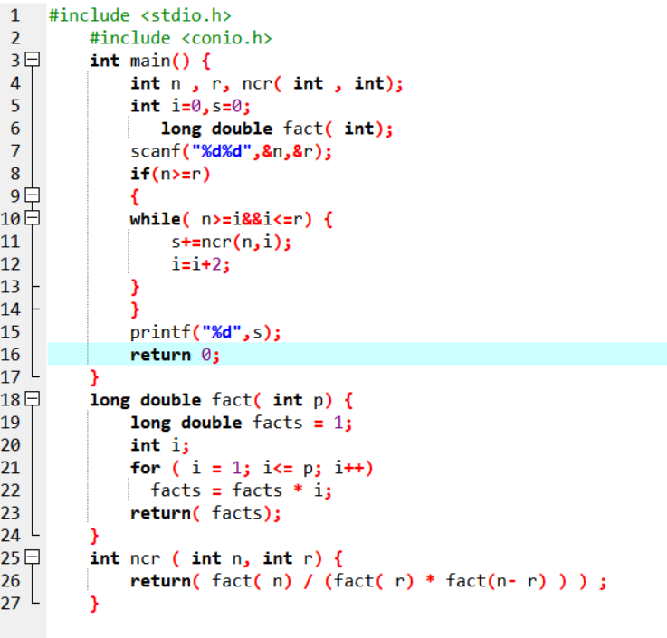

**2.3 Output:**

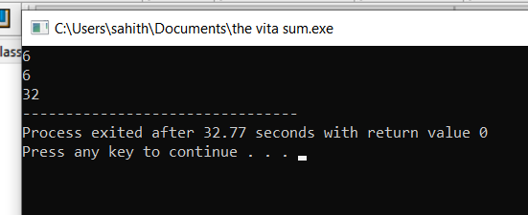

**Fig-2.3.1**

**3 Problem 2 :**

**Milk Man and His Bottles**

This is a problem where we are going to find the minimum number of bottles required

To supply the given demand of milk

**3.1 Problem statement:**

A Milkman serves milk in packaged bottles of varied sizes. The possible size of the bottles are {1, 5, 7 and 10} liters. He wants to supply desired quantity using as less bottles as possible irrespective of the size. Your objective is to help him find the minimum number of bottles required to supply the given demand of milk.

#### **Input Format:**

* First line contains number of test cases N
* Next N lines, each contain a positive integer Li which corresponds to the demand of milk.

#### **Output Format:**

* For each input Li, print the minimum number of bottles required to fulfill the demand

#### **Constraints:**

* 1 <= N <= 1000
* Li> 0
* 1 <= i <= N

#### **Sample Input and Output**

|  |  |  |
| --- | --- | --- |
| **SNo.** | **Input** | **Output** |
| **1** | **2**  **17**  **65** | **2**  **7** |

**Concepts used to solve :-**

For loop and if else concepts are used.

**For loop :**

A **for** loop is a repetition control structure that allows you to efficiently write a loop that needs to execute a specific number of times.

## Syntax :

## The syntax of a for loop in C programming language is −

for (initializationStatement; testExpression; updateStatement)

{

// statements inside the body of loop

}

## If-else Statement

The if-else statement is used to perform two operations for a single condition. The if-else statement is an extension to the if statement using which, we can perform two different operations, i.e., one is for the correctness of that condition, and the other is for the incorrectness of the condition. Here, we must notice that if and else block cannot be executed simiulteneously. Using if-else statement is always preferable since it always invokes an otherwise case with every if condition. The syntax of the if-else statement is given below.

**if**(expression){

//code to be executed if condition is true

}**else**{

//code to be executed if condition is false

}

**3.2 Coding**:

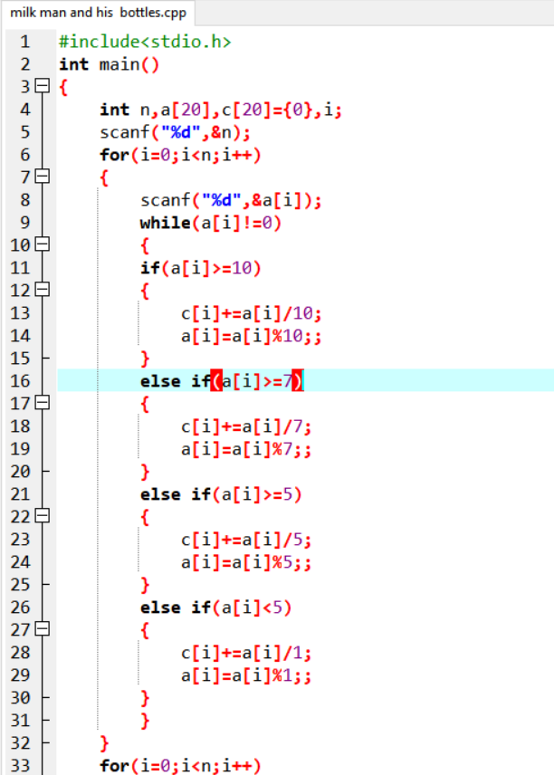

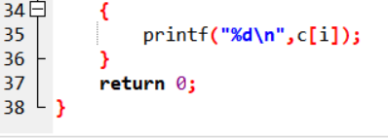

**3.3 Output:**

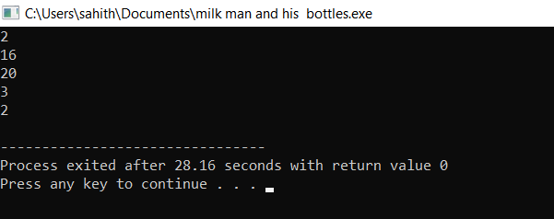

**Fig-3.3.1**

### 4 Problem 3:

### count bits

this is a problem where we are going tho find the number of inversions in the

Derived sequence

**4.1 Problem statement:**

Given a sequence of distinct numbers a1, a2, ….. an, an inversion occurs if there are indices i<j such that ai > aj .

For example, in the sequence 2 1 4 3 there are 2 inversions (2 1) and (4 3).

The input will be a main sequence of N positive integers. From this sequence, a Derived derived sequence will be obtained using the following rule. The output is the number of inversions in the derived sequence.

**Rule for forming derived sequence**

The derived sequence is formed by counting the number of 1s bits in the binary representation of the corresponding number in the input sequence.

Thus, if the input is 3,4,8, the binary representation of the numbers are 11,100 and 1000. The derived sequence is the number of 1sin the binary representation of the numbers in the input sequence, and is 2,1,1

### Constraints

N <= 50

Integers in sequence <= 107

### Input Format

The first line of the input will have a single integer, which will give N.

The next line will consist of a comma separated string of N integers, which is the main sequence

### Output

The number of inversions in the derived sequence formed from the main sequence.

### Explanation

Input

5

55, 53, 88, 27, 33

Output

8

Explanation

The number of integers is 5, as specified in the first line. The given sequence is 55, 53, 88, 27, 33.

The binary representation is 110111, 110101, 1011000, 11011, 100001and 100001 . The derived sequence is 5,4,3,4,2, 4,3,4,2 (corresponding to the number of 1s bits). The number of inversions in this is 8, namely (5,4),(5,3),(5,4),(5,2),(4,3),(4,2),(3,2),(4,2). Hence the output is 8.

**Concepts used to solve :-**

For loop and if else concepts are used.

**For loop :**

A **for** loop is a repetition control structure that allows you to efficiently write a loop that needs to execute a specific number of times.

## Syntax :

## The syntax of a for loop in C programming language is −

for (initializationStatement; testExpression; updateStatement)

{

// statements inside the body of loop

}

## If-else Statement

The if-else statement is used to perform two operations for a single condition. The if-else statement is an extension to the if statement using which, we can perform two different operations, i.e., one is for the correctness of that condition, and the other is for the incorrectness of the condition. Here, we must notice that if and else block cannot be executed simiulteneously. Using if-else statement is always preferable since it always invokes an otherwise case with every if condition. The syntax of the if-else statement is given below.

**if**(expression){

//code to be executed if condition is true

}**else**{

//code to be executed if condition is false

}

**4.2 Coding:**

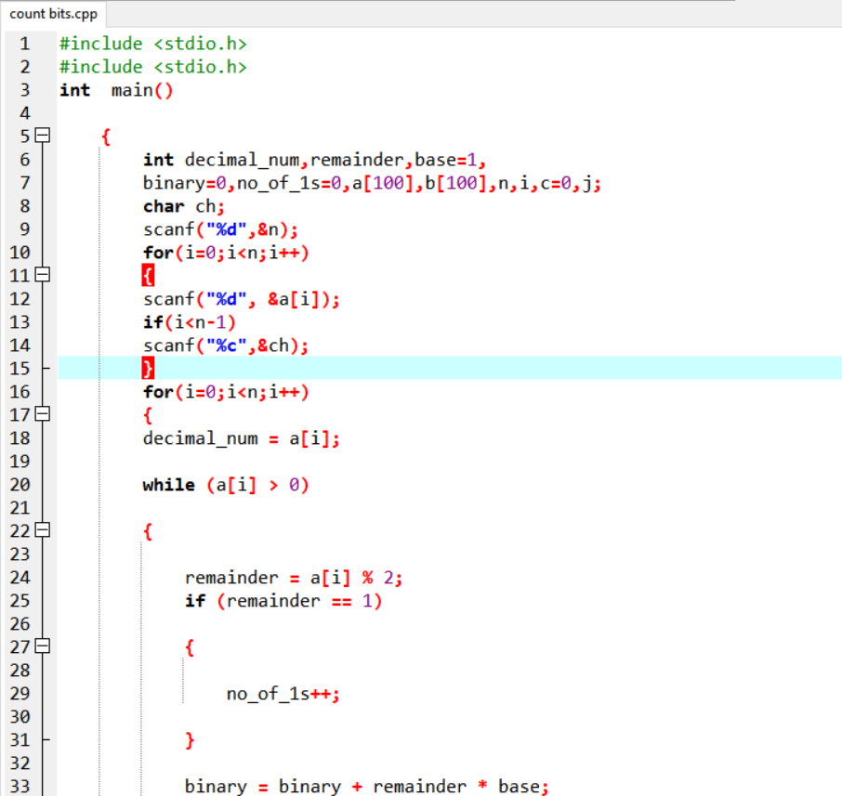

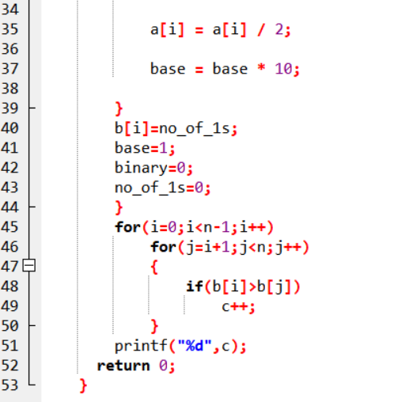

**4.3 Output:**

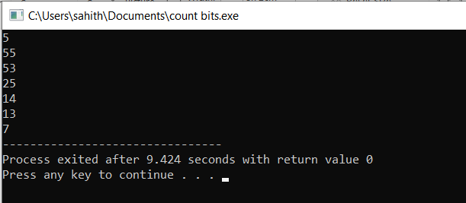

**Fig-4.3.1**

**5 Problem 4 :**

**Bug Crawl**

This is the problem where we are finding the initial position of the bug

**5.1 Problem statement:**

A cube has its 6 faces numbered from 1-6 (three of its faces are shown in the diagram). There are six possible orientations on the cube (U,D,N,E,W,S) as shown in the diagram, of which only 4 are possible on any one face (for example, on face 1, N and S are impossible orientations)

An electronic remote control bug is on a face of a cube at some orientation. On your command it can crawl around the cube. The possible commands are F,B,L,R.

Command F : it moves to the adjacent face in the same direction it is facing

.Command B : it turns around by 180° and moves forward by one face.

Command L: it turns left and moves forward by one face

Command R: it turns right and moves forward by one face.

The faces 4,5,6 are opposite to faces 1,2,3 respectively.

For example, if it has orientation U on face 1, on command L, it goes to face 5 and has orientation N, and from there on command F , it will move to face 4 and will have orientation E.

Given a sequence of commands, and the final position (face and orientation) of the bug (after executing the commands in the sequence), we need to determine the initial position (face and orientation) of the bug.

### Constraints

The length of the string of command letters <=50

### Input Format

One string of 2 characters giving the face and orientation of the bug after it executes the instructions. The first character is a number between 1 and 6, denoting the face, and the second character is the orientation (from the set {U, D, N, S, E, W}) of the bug after executing the commands

One string of command letters. This is a sequence of letters from the set of valid commands {F, B, L, R}

### Output

One string of two characters denoting the position of the bug before it executes the instructions. The first character gives the face number (1,2,3,...,6) and the second giving the orientation (E,W,U,D,N,S ) the bug was facing before it executed the instructions

### Explanation

Input

1U

FFF

Output

3N

Explanation

If the bug starts at 3N, it will move to 4D, 6S and 1U if a command F is given at each position. Hence, if it starts at 3N, after 3 consecutive F commands, it will be at 1U, which is the given final position. Hence the output is 3N.

Hence the output is 3E.

**Concepts used to solve :-**

For loop and if else concepts are used.

**For loop :**

A **for** loop is a repetition control structure that allows you to efficiently write a loop that needs to execute a specific number of times.

## Syntax :

## The syntax of a for loop in C programming language is −

for (initializationStatement; testExpression; updateStatement)

{

// statements inside the body of loop

}

## If-else Statement

The if-else statement is used to perform two operations for a single condition. The if-else statement is an extension to the if statement using which, we can perform two different operations, i.e., one is for the correctness of that condition, and the other is for the incorrectness of the condition. Here, we must notice that if and else block cannot be executed simiulteneously. Using if-else statement is always preferable since it always invokes an otherwise case with every if condition. The syntax of the if-else statement is given below.

**if**(expression){

//code to be executed if condition is true

}**else**{

//code to be executed if condition is false

}

**5.2 Coding:**

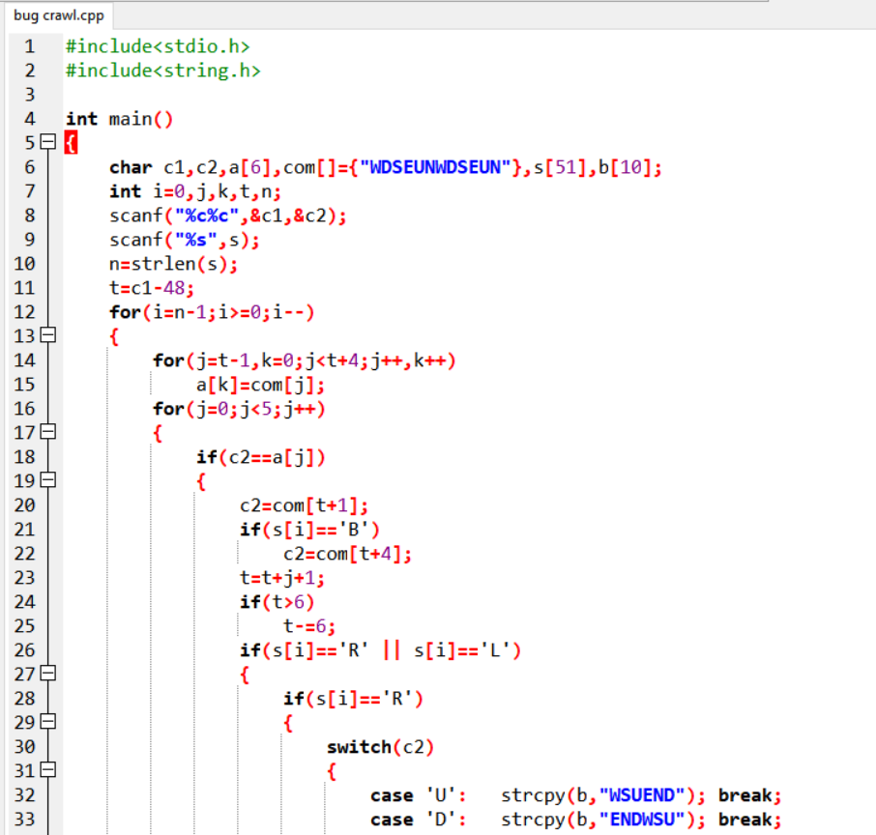

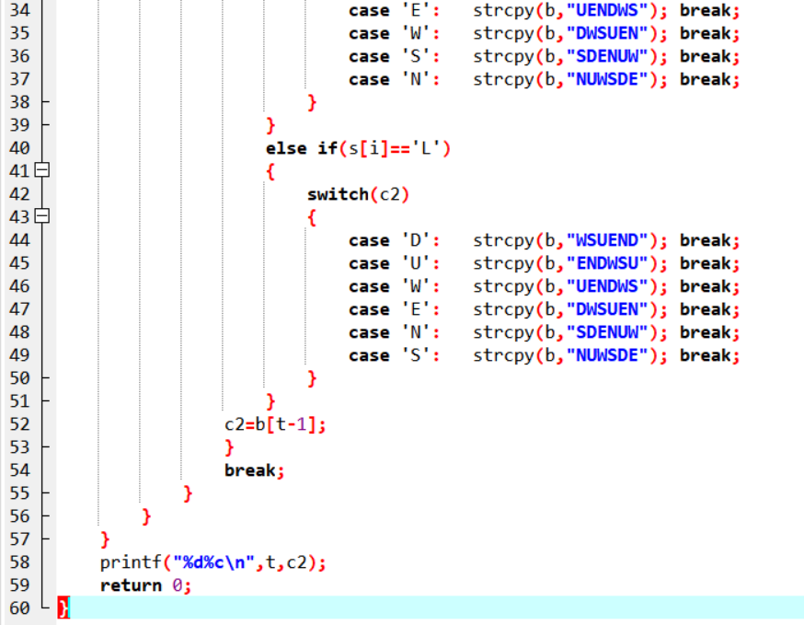

**5.3 Output:**

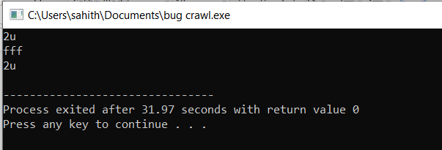

**Fig-5.3.1**

## ****6 Problem5:****

****Bank compare****

**This is a problem where we are going to find out the bank which has low interest rate**

****6.1 Problem statement:****

There are two banks – Bank A and Bank B. Their interest rates vary. You have received offers from both banks in terms of the annual rate of interest, tenure, and variations of the rate of interest over the entire tenure.You have to choose the offer which costs you least interest and reject the other. Do the computation and make a wise choice.

The loan repayment happens at a monthly frequency and Equated Monthly Installment (EMI) is calculated using the formula given below :

EMI = loanAmount * monthlyInterestRate / ( 1 – 1 / (1 + monthlyInterestRate)^(numberOfYears * 12))

**Constraints:**

* 1 <= P <= 1000000
* 1 <=T <= 50
* 1<= N1 <= 30
* 1<= N2 <= 30

**Input Format:**

* First line: P principal (Loan Amount)
* Second line: T Total Tenure (in years).
* Third Line: N1 is the number of slabs of interest rates for a given period by Bank A. First slab starts from the first year and the second slab starts from the end of the first slab and so on.
* Next N1 line will contain the interest rate and their period.
* After N1 lines we will receive N2 viz. the number of slabs offered by the second bank.
* Next N2 lines are the number of slabs of interest rates for a given period by Bank B. The first slab starts from the first year and the second slab starts from the end of the first slab and so on.
* The period and rate will be delimited by single white space.

**Output Format:**Your decision either Bank A or Bank B.

**Concepts used to solve :-**

For loop and if else concepts are used.

**For loop :**

A **for** loop is a repetition control structure that allows you to efficiently write a loop that needs to execute a specific number of times.

## Syntax :

## The syntax of a for loop in C programming language is −

for (initializationStatement; testExpression; updateStatement)

{

// statements inside the body of loop

}

## If-else Statement

The if-else statement is used to perform two operations for a single condition. The if-else statement is an extension to the if statement using which, we can perform two different operations, i.e., one is for the correctness of that condition, and the other is for the incorrectness of the condition. Here, we must notice that if and else block cannot be executed simiulteneously. Using if-else statement is always preferable since it always invokes an otherwise case with every if condition. The syntax of the if-else statement is given below.

1. **if**(expression){
2. //code to be executed if condition is true
3. }**else**{
4. //code to be executed if condition is false
5. }

**6.2 Coding:**

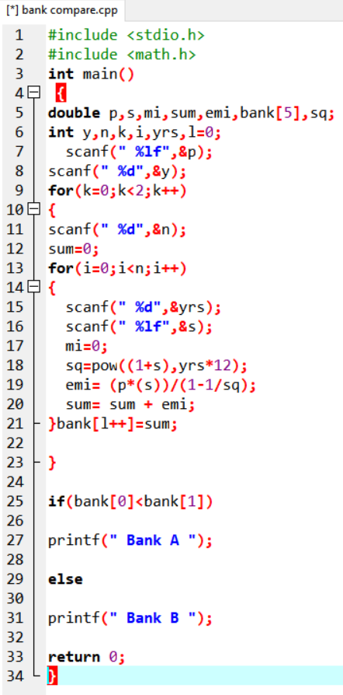

**6.3 Output:**

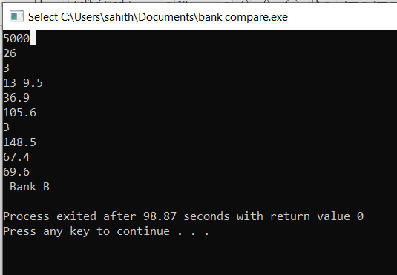

**Fig-6.3.1**

# **7 Software Requirements**

## **7.1  Hardware Requirements**

This project can be executed in any system or an android phone without prior to any platform.

We can use any online compiler and interpreter.

## **7.2 Software Requirements**

There are two ways to execute this projects

Online compilers

Software's for execution (DEV C++, ANACONDA…..)

Online Compilers require only internet connection. We have many free compilers with which we can code.

Software for execution need to be installed based on the user’s system specification. These help us to completely execute the project. These software's are based on the platforms

**8 Reference**

<https://prepinsta.com/tcs-codevita/practice-questions-with-answers/>

<https://www.geeksforgeeks.org/>

<https://www.faceprep.in/tcs/tcs-codevita-questions/>